**COMSATS University Islamabad, Vehari Campus**

**Name: Abdul Salam Registration Number: SP22-BCS-121 Department: Computer Science**

**Course: DSA**

**Instructor: Yasmeen Jana**

**Assignment: 1st**

**Section: B**

# Activity 1

function to display linked list

**Solution:**

C++

#include <iostream> using namespace std;

class Node

{

public:

int data;

Node* next;

Node(int data)

{

this->data=data;

this->next=NULL;

}

};

//Print using while loop void print(Node* &head)

{

Node* temp=head;

cout<<" Linked List is:\n ";

while(temp!=NULL)

{

cout<<temp->data<<" ";

temp=temp->next;

}

cout<<endl;

Node* ptr=head;

//cout<<"Linked List is:\n";

cout<<" ****head address:**** "<<&head<<endl;

cout<<" \n";

cout<<" head content:"<<head<<endl;

cout<<" \n";

cout<<" ****ptr address:**** "<<&ptr<<endl;

cout<<" \n";

cout<<" ptr content:"<<ptr<<endl;

cout<<" \n";

cout<<" ptr->data: "<<ptr->data<<endl;

cout<<" \n";

ptr=ptr->next;

while(ptr!=NULL)

{

|  |  |  |
| --- | --- | --- |
| cout<<" ptr: "<<ptr<<endl; | |  |
| cout<<" ptr->next: "<<ptr->next<<endl; | | |
| cout<<" ptr->data: "<<ptr->data<<endl; | | |
|  |  | |

cout<<" \n";

ptr=ptr->next;

}

}

int main()

{

Node* head=NULL;

Node* node1=new Node(1);

head=node1;

Node* node2=new Node(2);

node1->next=node2;

Node* node3=new Node(20);

node2->next=node3;

Node* node4=new Node(30);

node3->next=node4;

print(head);

}

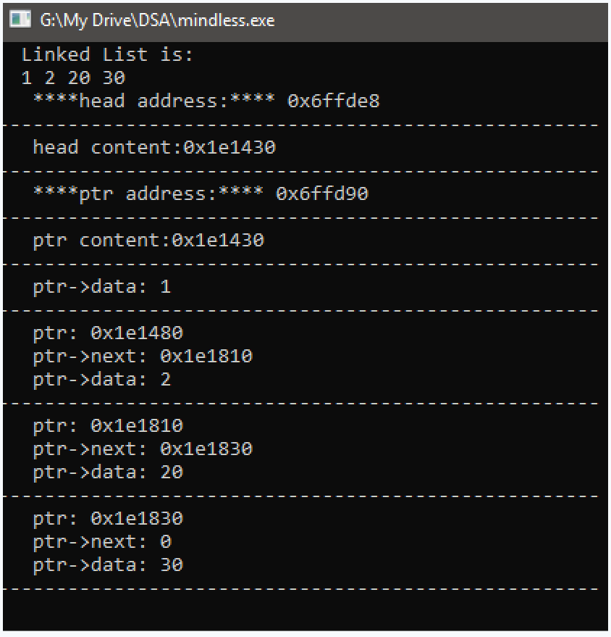

# Activity 2(a)

Menu Singly Linked List:

**Solution:**

C++

#include <iostream> #include <conio.h> using namespace std;

class Node {

public:

int data;

Node* next;

Node(int data)

{

this->next=NULL;

this->data=data;

}

};

void seek(Node* head) {

int target;

std::cout << "Enter the value you want to seek: ";

std::cin >> target;

Node* current = head;

int flag=0;

while (current != NULL) {

if (current->data == target) {

std::cout << "Value " << target << " found in the list." << std::endl;

flag++;

}

current = current->next;

}

if(flag==0)

{

std::cout << "Value " << target << " not found in the list." << std::endl;

}

}

void reverseAndPrint(Node*& head) {

Node* prev = NULL;

Node* current = head;

Node* next = NULL;

while (current != NULL) {

next = current->next; // Store the next node.

current->next = prev; // Reverse the current node's pointer to the previous node.

prev = current; // Move the 'prev' pointer to the current node.

current = next; // Move the 'current' pointer to the next node.

}

head = prev; // Update the head to point to the new first node (previous last node).

// Print the reversed list.

cout<<"reversed linked list is:";

current = head;

while (current != NULL) {

std::cout << current->data << " -> ";

current = current->next;

}

std::cout << "NULL" << std::endl;

}

void deleteAtEnd(Node*& head) {

if (head == NULL) {

cout << "List is empty. Cannot delete from an empty list." << endl;

return;

}

if (head->next == NULL) {

// If there is only one node in the list, delete it and set head to nullptr.

delete head;

head = NULL;

cout<<"deleted successfully!\n";

return;

}

Node* current = head;

while (current->next->next != NULL) {

current = current->next;

}

delete current->next;

current->next = NULL;

cout<<"deleted successfully!\n";

}

void deleteAtBegining(Node*& head) {

if (head == NULL) {

cout << "List is empty. Cannot delete from an empty list." << std::endl;

return;

}

Node* temp = head;

head = head->next;

delete temp;

cout<<"deleted successfully!\n";

}

void deleteAnyValue(Node* &head)

{

if(head==NULL)

{

cout<<"Linked List is empty so Deletion not Possible";

return;

} int V,data;

cout<<"For deletion At Value, Enter Any Value in Link List:";

cin>>V;

int flag=0;

Node* temp=head;

while(temp->next->data!=V && temp->next->next!=NULL)

{

temp=temp->next;

}

if(temp->next->data==V)

{

Node* ptr=temp->next;

temp->next=temp->next->next;

delete ptr;

flag++;

}

if(head->data==V)

{

Node* ptr=head;

head=head->next;

delete ptr;

flag++;

}

if(flag==0)

{

cout<<"Value does not exist in the Linked list\n";

}

}

void insertAtAnyValue(Node* &head)

{

int V,data;

cout<<"For insertion At Value, Enter Any Value in Link List:";

cin>>V;

int flag=0;

Node* temp=head;

while(temp->next->data!=V && temp->next->next!=NULL)

{

temp=temp->next;

}

if(temp->next->data==V)

{ cout<<"Enter value of Node:";

cin>>data;

Node* ptr=new Node(data);

ptr->next=temp->next;

temp->next=ptr;

cout<<"inserted successfully!\n";

flag++;

}

if(head->data==V)

{ cout<<"Enter value of Node:";

cin>>data;

Node* ptr=new Node(data);

ptr->next=head;

head=ptr;

cout<<"inserted successfully!\n";

flag++;

}

if(flag==0)

{

cout<<"Value does not exist in the Linked list and not inserted successfully!\n";

}

}

void insertAtEnd(Node* &head,int data)

{

if(head==NULL)

{

Node* node1=new Node(data);

node1->next=head;

head=node1;

}

else

{

Node* temp=head;

while(temp->next!=NULL)

{

temp=temp->next;

}

Node* lastNode=new Node(data);

temp->next=lastNode;

}

}

void print(Node* &head)

{

if(head==NULL)

{

cout<<"Linked List is Empty";

}

else

{ cout<<"The items present in the List are:";

Node* temp=head;

while(temp!=NULL)

{

cout<<temp->data<<" ";

temp=temp->next;

}

cout<<endl;

}

}

void insertAtBeginingsingly(Node* &head,int data)

{

Node* node1=new Node(data);

node1->next=head;

head=node1;

}

int main() {

int operation;

Node* singlyList = NULL; // head of singly linked list

do {

cout << "\n\nWhich operation you want to perform:" << endl;

cout << "1: Insertion" << endl;

cout << "2: Deletion" << endl;

cout << "3: Display" << endl;

cout << "4: Reverse" << endl;

cout << "5: Seek" << endl;

cout << "6: Back to Previous Menu" << endl;

cout << "Enter your choice: ";

cin >> operation;

if (operation == 6) {

break; // exit

}

// Handle Insertion

if (operation == 1) {

int insertionOption;

do {

cout << "\n\nInsertion Options:" << endl;

cout << "1: Insert at the beginning" << endl;

cout << "2: Insert at the end" << endl;

cout << "3: Insert at a specific data node" << endl;

cout << "4: Back to Previous Menu" << endl;

cout << "Enter your choice: ";

cin >> insertionOption;

if (insertionOption == 4) {

break; // Return to the previous menu

}

|  |  |  |  |  |  |  |  |  |  |  |  |  |  |
| --- | --- | --- | --- | --- | --- | --- | --- | --- | --- | --- | --- | --- | --- |
| switch (insertionOption) { | | | | | | | | |  | | | | |
| case 1: | | | |  | | | | | | | | | |
| { int data; | | | | | | | |  | | | | | |
| cout<<"Enter the Value to insert:"; | | | | | | | | | | | | |  |
| cin>>data; | | | | | |  | | | | | | |
|  | | | | | | |  | | | | | |
| insertAtBeginingsingly(singlyList,data); | | | | | | |  | | | | | |
| cout<<"inserted | | | | | | | | | | | |  |
| successfully!\n"; | |  | | | | | | | | | | |
| print(singlyList); | | | | | | | | | | | | |
| char c; | | | | | | | | | |  | | |
| cout<<"Press any key to | | | | | | | | | | | | | |
| continue..."; |  | | | | | | | | | | | | |
| getch(); | | | | | | | | | | |  | | |
| break; | | | | |  | | | | | | | | |
| } | | | | | | | |  | | | | | |
| case 2: | | | |  | | | | | | | | | |
| { int data; | | | | | | | |  | | | | | |
| cout<<"Enter the Value to insert:"; | | | | | | | | | | | | |  |
| cin>>data; | | | | | |  | | | | | | |
|  | | | | | | |  | | | | | |
| insertAtEnd(singlyList,data); | | |  | | | | | | | | | |
| cout<<"inserted | | | | | | | | | | | |  |
| successfully!\n"; | |  | | | | | | | | | | |
| print(singlyList); | | | | | | | | | | | | |
| char c; | | | | | | | | | |  | | |

cout<<"Press any key to

continue...";

getch();

break;

}

case 3:

{ insertAtAnyValue(singlyList);

char c;

cout<<"\nPress any key to

continue...";

getch();

break;

}

{

cout << "Invalid option. Please try again."

<< endl;

break;

}

}

default:

print(singlyList);

|  |  |  |
| --- | --- | --- |
|  | } while (true);  if (operation == 2) { | |
| } |
|  |
| int deletionOption; | |  |

do {

cout << "\n\nDeletion Options:" << endl;

cout << "1: Delete at the beginning" << endl;

cout << "2: Delete at the end" << endl;

cout << "3: Delete at a specific data node" << endl;

cout << "4: Back to Previous Menu" << endl;

cout << "Enter your choice: ";

cin >> deletionOption;

if (deletionOption == 4) {

break; // Return to the previous menu

}

|  |  |  |  |  |  |
| --- | --- | --- | --- | --- | --- |
| switch (deletionOption) { | | | |  | |
| case 1: | |  | | | |
| { |  | | | | |
|  | | |  | | |
| deleteAtBegining(singlyList); |  | | | | |
| print(singlyList); | | | | | |
| char c; | | | | |  |

|  |  |  |  |  |  |  |  |  |  |  |  |  |  |  |  |  |  |
| --- | --- | --- | --- | --- | --- | --- | --- | --- | --- | --- | --- | --- | --- | --- | --- | --- | --- |
| cout<<"Press any key to | | | | | | | | | | | | | | |  | | |
| continue..."; | |  | | | | | | | | | | | | | | | |
| getch(); | | | | | | | | | | | |  | | | | | |
| break; | | | | | | | | |  | | | | | | | | |
| } | | | | | | | | | |  | | | | | | | |
| case 2: | | | | | | |  | | | | | | | | | | |
| { | | | | | |  | | | | | | | | | | | |
| deleteAtEnd(singlyList); | | | | | | | | | | | | | | | |  | |
| print(singlyList); | | | | | | | | | | | | | |  | | | |
| char c; | | | | | | | | | | |  | | | | | | |
| cout<<"Press any key to | | | | | | | | | | | | | | |  | | |
| continue..."; | |  | | | | | | | | | | | | | | | |
| getch(); | | | | | | | | | | | |  | | | | | |
| break; | | | | | | | | |  | | | | | | | | |
| } | | | | | | | | | |  | | | | | | | |
| case 3: | | | | | | |  | | | | | | | | | | |
| { deleteAnyValue(singlyList); | | | | | | | | | | | | |  | | | | |
| print(singlyList); | | | | | | | | | | | | | |  | | | |
| char c; | | | | | | | | | | |  | | | | | | |
| cout<<"\nPress any key to | | | | | | | | | | | | | | | | |  |
| continue..."; | |  | | | | | | | | | | | | | | |
| getch(); | | | | | | | | | | | |  | | | | |
| break; | | | | | | | | |  | | | | | | | |
| } | | | | | | | | | |  | | | | | | |
| default: | | | | | | | |  | | | | | | | | |
| { | | | | | |  | | | | | | | | | | |
| cout << "Invalid option. Please try again." | | | | | | | | | | | | | | | | | |
| << endl; |  | | | | | | | | | | | | | | | | |
| break; | | | | | | | | |  | | | | | | | | |
| } | | | | | | | | | |  | | | | | | | |
| } | | | |  | | | | | | | | | | | | | |
|  | | | | |  | | | | | | | | | | | | |
|  | | | | | |  | | | | | | | | | | | |
|  | | |  | | | | | | | | | | | | | | |

|  |  |  |  |  |  |  |  |  |
| --- | --- | --- | --- | --- | --- | --- | --- | --- |
| } while (true); | | | | | | |  | |
| } | |  | | | | | | |
| if(operation==3) | | | |  | | | | |
| { |  | | | | | | | |
| print(singlyList); | | | | | |  | | |
| } | |  | | | | | | |
| if(operation==4) | | | | |  | | | |
| { | |  | | | | | | |
| reverseAndPrint(singlyList); | | | | | | | | |
| } | |  | | | | | | |
| if(operation==5) | | | |  | | | | |
| { | |  | | | | | | |
| seek(singlyList); | | | | | | | |  |
|  | | } | | | | | |
| } while (true); | | |  | | | | |

return 0;

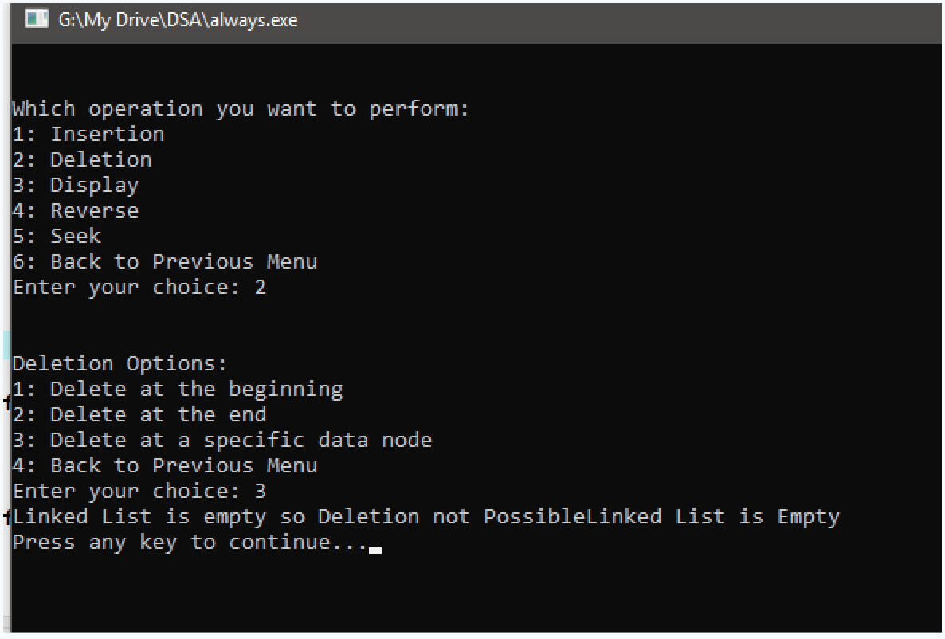}

# Activity 2(b)

Menu Doubly Linked List:

**Solution:**

C++

#include <iostream> #include <conio.h> using namespace std;

class NodeDoubly {

public:

int data;

NodeDoubly* next;

NodeDoubly* prev;

NodeDoubly(int data)

{

this->next=NULL;

|  |  |
| --- | --- |
| this->data=data; | |
| this->prev=NULL; | |
|  |  |

}

};

void seek(NodeDoubly* head) {

int targetData;

std::cout << "Enter the value you want to seek: ";

std::cin >> targetData;

NodeDoubly* current = head;

bool found = false;

while (current != NULL) {

if (current->data == targetData) {

found = true;

std::cout << "Value " << targetData << " found in the list." << std::endl;

return;

}

current = current->next;

}

if (!found) {

std::cout << "Value " << targetData << " not found in the list." << std::endl;

}

}

void reverseAndPrint(NodeDoubly* &head) {

if (head == NULL) {

std::cout << "List is empty. Nothing to reverse and print." << std::endl;

return;

}

NodeDoubly* current = head;

while (current->next != NULL) {

current = current->next;

}

std::cout << "Reversed List:" << std::endl;

while (current != NULL) {

std::cout << (current->next ? "<-" : "") << current->data << "

-> ";

current = current->prev;

}

std::cout << "NULL" << std::endl;

}

void deleteSpecificDataNode(NodeDoubly*& head) {

int targetData;

std::cout << "Enter the value you want to delete: ";

std::cin >> targetData;

if (head == NULL) {

std::cout << "List is empty. Cannot delete from an empty list."

<< std::endl;

return;

}

if (head->data == targetData) {

NodeDoubly* temp = head;

head = head->next;

if (head != NULL) {

head->prev = NULL;

}

delete temp;

return;

}

NodeDoubly* current = head;

while (current != NULL) {

if (current->data == targetData) {

current->prev->next = current->next;

if (current->next != NULL) {

current->next->prev = current->prev;

}

delete current;

return;

}

current = current->next;

}

std::cout << "Value " << targetData << " not found in the list." << std::endl;

}

void deleteAtEnd(NodeDoubly*& head) {

if (head == NULL) {

std::cout << "List is empty. Cannot delete from an empty list."

<< std::endl;

return;

}

if (head->next == NULL) {

// If there's only one node in the list, delete it and set head to NULL.

delete head;

head = NULL;

return;

}

NodeDoubly* current = head;

while (current->next->next != NULL) {

current = current->next;

}

delete current->next;

current->next = NULL;

}

void deleteAtHead(NodeDoubly*& head) {

if (head == NULL) {

std::cout << "List is empty. Cannot delete from an empty list."

<< std::endl;

return;

}

NodeDoubly* temp = head;

head = head->next;

if (head != NULL) {

head->prev = NULL;

}

delete temp;

}

void insertAtSpecificDataNode(NodeDoubly*& head, int dataToInsert) {

int dataAfter;

std::cout << "Enter the value after which you want to insert: ";

std::cin >> dataAfter;

NodeDoubly* new_node = new NodeDoubly(dataToInsert);

NodeDoubly* current = head;

while (current != NULL) {

if (current->data == dataAfter) {

new_node->prev = current;

new_node->next = current->next;

if (current->next != NULL) {

current->next->prev = new_node;

}

current->next = new_node;

return;

}

current = current->next;

}

}

void insertAtEnd(NodeDoubly*& head, int data) {

NodeDoubly* new_node = new NodeDoubly(data);

NodeDoubly* current = head;

if (head == NULL) {

head = new_node;

} else {

while (current->next != NULL) {

current = current->next;

}

current->next = new_node;

new_node->prev = current;

}

}

void Display(NodeDoubly* head) {

NodeDoubly* current = head;

while (current != NULL) {

std::cout << (current->prev ? "<-" : "") << current->data << "

-> ";

current = current->next;

}

std::cout << "NULL" << std::endl;

}

void insertAtHead(NodeDoubly*& head, int data) {

NodeDoubly* new_node = new NodeDoubly(data);

if (head ==NULL) {

head = new_node;

} else {

new_node->next = head;

head->prev = new_node;

head = new_node;

}

}

int main() {

int operation;

NodeDoubly* singlyList=NULL;

NodeDoubly* dhead = NULL; // head of singly linked list

do {

cout << "\n\nWhich operation you want to perform:" << endl;

cout << "1: Insertion" << endl;

cout << "2: Deletion" << endl;

cout << "3: Display" << endl;

cout << "4: Reverse" << endl;

cout << "5: Seek" << endl;

cout << "6: Back to Previous Menu" << endl;

cout << "Enter your choice: ";

cin >> operation;

if (operation == 6) {

break; // exit

}

// Handle Insertion

if (operation == 1) {

int insertionOption;

do {

cout << "\n\nInsertion Options:" << endl;

cout << "1: Insert at the beginning" << endl;

cout << "2: Insert at the end" << endl;

cout << "3: Insert at a specific data node" << endl;

cout << "4: Back to Previous Menu" << endl;

cout << "Enter your choice: ";

cin >> insertionOption;

if (insertionOption == 4) {

break; // Return to the previous menu

}

|  |  |  |  |  |  |  |  |  |  |  |
| --- | --- | --- | --- | --- | --- | --- | --- | --- | --- | --- |
| switch (insertionOption) { | | | | | |  | | | | |
| case 1: | | |  | | | | | | | |
| { int data; | | | | |  | | | | | |
| cout<<"Enter the Value to insert:"; | | | | | | | | |  | |
| cin>>data; | | | |  | | | | | | |
| insertAtHead(dhead,data); | | | | | | | | | | |
| cout<<"inserted | | | | | | | |  | | |
| successfully!\n"; | |  | | | | | | | | |
| Display(dhead); | | | | | | | |  | | |
| char c; | | | | | | |  | | | |
| cout<<"Press any key to | | | | | | | | | |  |
| continue..."; |  | | | | | | | | |

break; case 2:

getch();

}

cout<<"Enter the Value to insert:";

{ int data;

successfully!\n";

continue...";

cout<<"Enter cin>>data;

break;

the Value to insert:";

insertAtEnd(dhead,data); cout<<"inserted

Display(dhead); char c;

cout<<"Press any key to getch();

}

case 3:

{ int data;

cin>>data;

insertAtSpecificDataNode(dhead,data);

Display(dhead); char c;

cout<<"\nPress any key to

continue...";

getch();

break;

}

{

cout << "Invalid option. Please try again."

<< endl;

break;

}

}

default:

|  |  |  |
| --- | --- | --- |
|  | } while (true);  if (operation == 2) { | |
| } |
|  |
| int deletionOption; | |  |

do {

cout << "\n\nDeletion Options:" << endl;

cout << "1: Delete at the beginning" << endl;

cout << "2: Delete at the end" << endl;

cout << "3: Delete at a specific data node" <<

endl;

cout << "4: Back to Previous Menu" << endl;

cout << "Enter your choice: ";

cin >> deletionOption;

if (deletionOption == 4) {

break; // Return to the previous menu

}

|  |  |  |  |  |  |  |  |  |  |  |  |  |  |  |  |  |  |  |  |
| --- | --- | --- | --- | --- | --- | --- | --- | --- | --- | --- | --- | --- | --- | --- | --- | --- | --- | --- | --- |
| switch (deletionOption) { | | | | | | | | | | |  | | | | | | | | |
| case 1: | | | | | | |  | | | | | | | | | | | | |
| { | | | | | |  | | | | | | | | | | | | | |
| deleteAtHead(dhead); | | | | | | | | | | | | | | | | |  | | |
| Display(dhead); | | | | | | | | | | | | | |  | | | | | |
| char c; | | | | | | | | | | | |  | | | | | | | |
| cout<<"Press any key to | | | | | | | | | | | | | | | | | |  | |
| continue..."; | |  | | | | | | | | | | | | | | | | | |
| getch(); | | | | | | | | | | | | |  | | | | | | |
| break; | | | | | | | | |  | | | | | | | | | | |
| } | | | | | | | | | |  | | | | | | | | | |
| case 2: | | | | | | |  | | | | | | | | | | | | |
| { | | | | | |  | | | | | | | | | | | | | |
| deleteAtEnd(dhead); | | | | | | | | | | | | | | | |  | | | |
| Display(dhead); | | | | | | | | | | | | | |  | | | | | |
| char c; | | | | | | | | | | | |  | | | | | | | |
| cout<<"Press any key to | | | | | | | | | | | | | | | | | |  | |
| continue..."; | |  | | | | | | | | | | | | | | | | | |
| getch(); | | | | | | | | | | | | |  | | | | | | |
| break; | | | | | | | | |  | | | | | | | | | | |
| } | | | | | | | | | |  | | | | | | | | | |
| case 3: | | | | | | |  | | | | | | | | | | | | |
| { deleteSpecificDataNode(dhead); | | | | | | | | | | | | | | |  | | | | |
| Display(dhead); | | | | | | | | | | | | | |  | | | | | |
| char c; | | | | | | | | | | | |  | | | | | | | |
| cout<<"\nPress any key to | | | | | | | | | | | | | | | | | | |  |
| continue..."; | |  | | | | | | | | | | | | | | | | |
| getch(); | | | | | | | | | | | | |  | | | | | |
| break; | | | | | | | | |  | | | | | | | | | |
| } | | | | | | | | | |  | | | | | | | | |
| default: | | | | | | | |  | | | | | | | | | | |
| { | | | | | |  | | | | | | | | | | | | |
| cout << "Invalid option. Please try again." | | | | | | | | | | | | | | | | | | | |
| << endl; |  | | | | | | | | | | | | | | | | | | |
| break; | | | | | | | | |  | | | | | | | | | | |
| } | | | | | | | | | |  | | | | | | | | | |
| } | | | |  | | | | | | | | | | | | | | | |
|  | | | | |  | | | | | | | | | | | | | | |
|  | | | | | |  | | | | | | | | | | | | | |
|  | | |  | | | | | | | | | | | | | | | | |

} while (true);

|  |  |  |  |  |
| --- | --- | --- | --- | --- |
| } | | |  | |
| if(operation==3) | | | | |
| { | Display(dhead); | | | |
|  |
| } | |  | | |
| if(operation==4) | | | | |
| { | | reverseAndPrint(dhead); | | |
|  | |
| } | |
| if(operation==5) | | | | |
| { | | seek(dhead); | | |
|  | |
| } | | | |  |
| } while (true); | | | | |

return 0;

